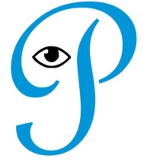 Cami-Patch Products July – Dec 2019

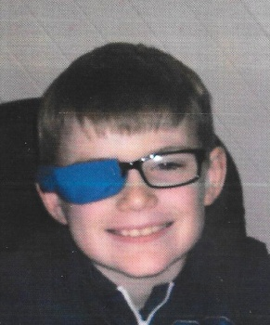 Cami-Sleeve order form

ABN 24 990 753 453

45 Rickard Rd, Empire Bay NSW 2257 Mobile: 0414 434 172 Phone: (02) 4369 4172

Email: camipatch@gmail.com [www.camipatch.com](http://www.camipatch.com)

Cameron’s original

Eye Patch 2013.

Cami-Sleeve adult’s range. (Cami-Patch caters for kids.)

|  |  |  |  |  |
| --- | --- | --- | --- | --- |
| Lycra/elastane  stretch fabrics. | Description **(RRP $10)**  One size fits most frames. | Qty | Wholesale price | Total |
| Anemone | Varied anemone hues |  | $6 |  |
| Deep sea | Blue and black |  | $6 |  |
| Flamingo | Varied patterns |  | $6 |  |
| Glasses, of course | Black frame on white |  | $6 |  |
| Midnight garden | Backed with black rib |  | $6 |  |
| Night | Plain black ribbing |  | $6 |  |
| Seaside | Blue or green & black- gold flecks, varied |  | $6 |  |
| Seasons | Stretch cotton |  |  |  |
| Spring | Abstract floral designs |  | $6 |  |
| Summer | Stronger floral colours |  | $6 |  |
| Winter | Blue /white |  | $6 |  |
|  |  |  |  |  |
| * **Size 13-14 cm X 6.5 cm** | Fits either side of frame. |  |  |  |
| Special orders | Smaller/larger made to order. |  |  |  |
| Handi-bags, 5 pack | Individually wrapped. |  | $30 |  |
|  |  |  |  |  |
| 30 day money back quality guarantee. | Postage at cost. FIS  Free for orders over $100 |  | **Total** |  |

* Approximate, depends on pattern. Patches lined. Care instructions on packet back.

Practice:________________________________ Date: / /

Address:______________________________________________

_____________________________________________________

Contact: _________________ Phone:_______________________

Commonwealth Bank BSB: 062 627 Acct: 10341766 CamiPatch Products. *Trish* *Skehan.*